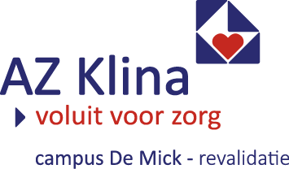
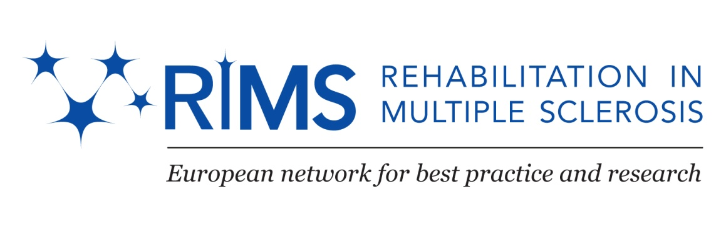

In between meeting: Special Interest Group (SIG) on Communication and Swallowing

Brasschaat, Belgium

Local Organizers: Margaux De Groote and Joke Raats

Chair and Co-Chair SIG Swallow: Margaux De Groote (B) and Francesca De Biagi (I)

RIMS Chair: Peter Feys (B)

Accommodation: Hotel Dennenhof. www.dennenhof.be

Program Meeting

Wednesday November 25th
From 18.00 – Welcome Diner

Thursday November 26th

Meeting Venue:
Baudetzaal, Rehabilitation Centre De Mick, AZ Klina, Papestraat 30, 2930 Brasschaat

08.45- 09.00 Registration

09.00- 09.10 Welcome

09.10- 10.10 Presentation: ‘Group Therapy’ (part one)
Dorien Van Den Borre

10.10-10.25 Coffee Break

10.25- 11.25 Presentation: ‘Group Therapy’ (part two)
Dorien Van Den Borre

11.30- 12.15 Guided tour in our Rehabilitation Centre
Margaux De Groote

12.15- 13.00 Lunch

13.00- 14.30 Presentation: ‘Basics of Methodology’ (part one)
Joke Raats

14.30- 14.50 Coffee Break

14.50- 16.15 Workshop: ‘Basics of Methodology’ (part two)
Joke Raats

18.00- 19.15 Guided tour Antwerp
Annie De Maeyer

19.15- … Diner

Friday November 27th

Meeting Venue:
Baudetzaal, Rehabilitation Centre De Mick, AZ Klina, Papestraat 30, 2930 Brasschaat

08.30- 10.00 Running project of the SIG: Group Therapy
Margaux De Groote

10.00-10.20 Coffee Break

10.20- 12.00 Grant Project: DYMUS (Dysphagia in Multiple Sclerosis) questionnaire
Marta Renom

12.15- 13.00 Lunch

13.00- 14.30 SIG future plans and goals
Margaux De Groote- Francesca De Biagi

End of the meeting

